# CS 255 System Design Document Template

## UML Diagrams

### UML Use Case Diagram

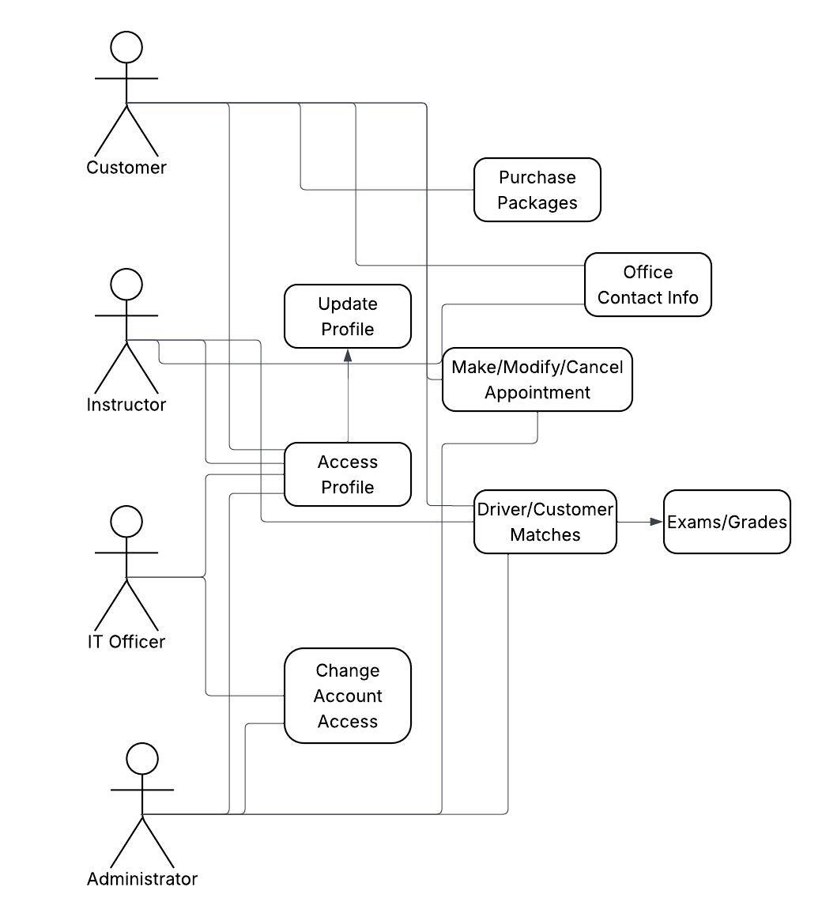

### UML Activity Diagrams

### UML Sequence Diagram

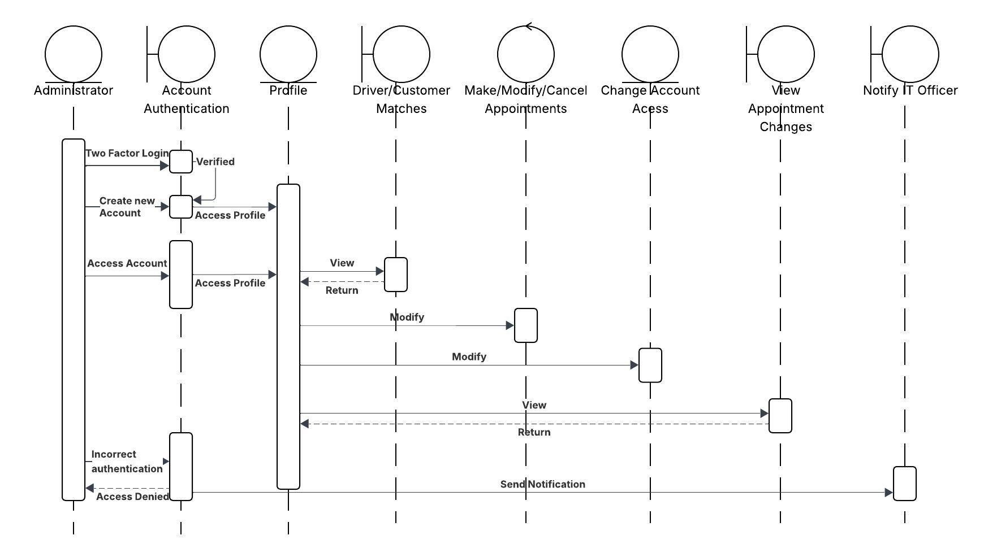

### UML Class Diagram

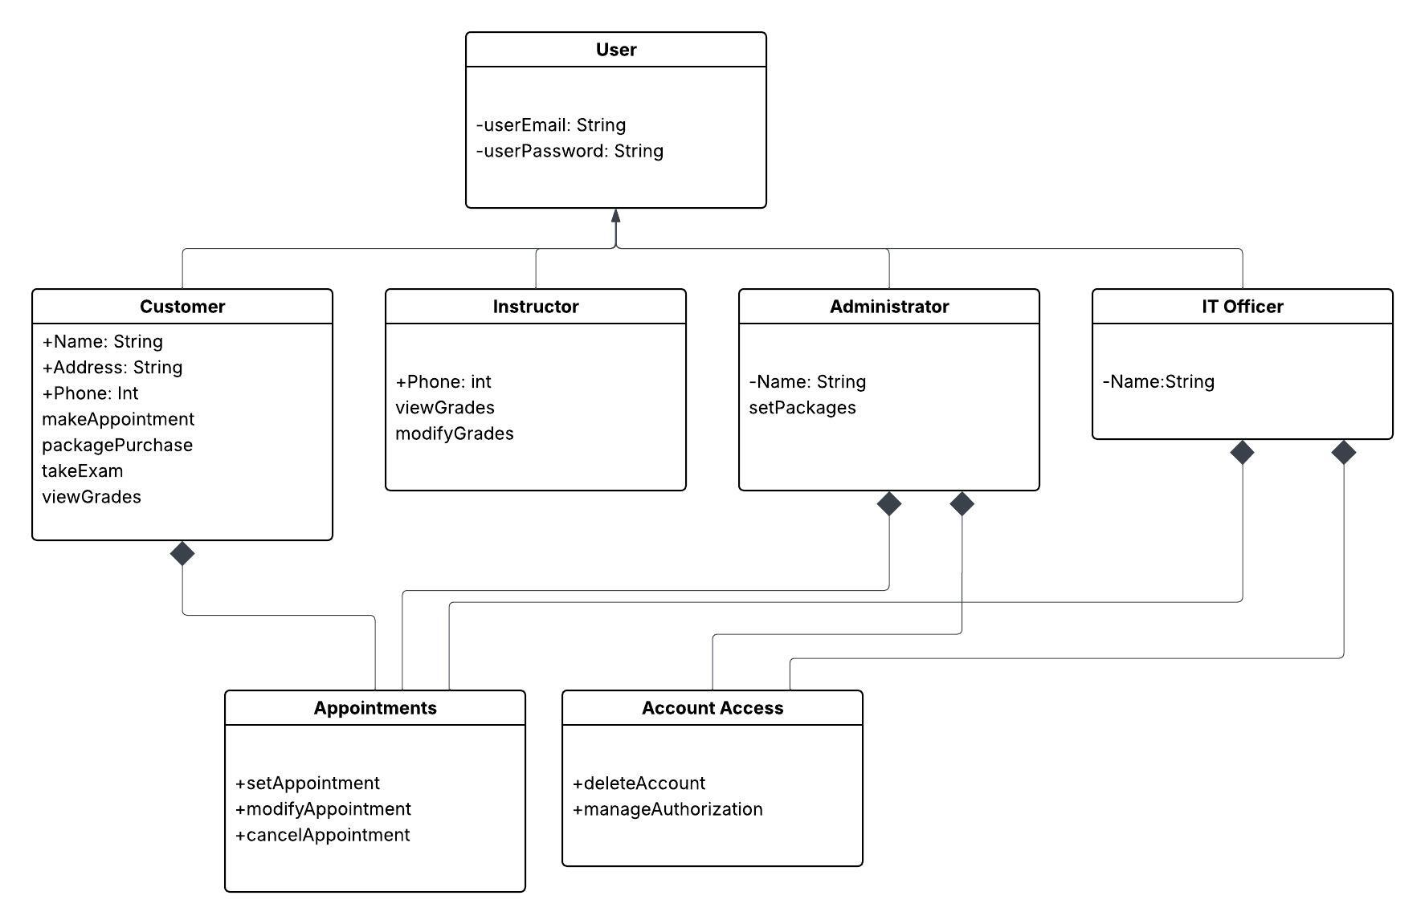

## Technical Requirements

Based on the diagrams shown, hardware requirements would include a server (which could also be done via a Cloud service such as Google Cloud for data security and storage), computers for each user (either desktop or laptop), a Smart Phone for mobile access, and an internet router. Required software would include a capable browser (like Chrome, Safari, or Firefox), an internet provider, and a security software (if using a Cloud data service, security may be provided).